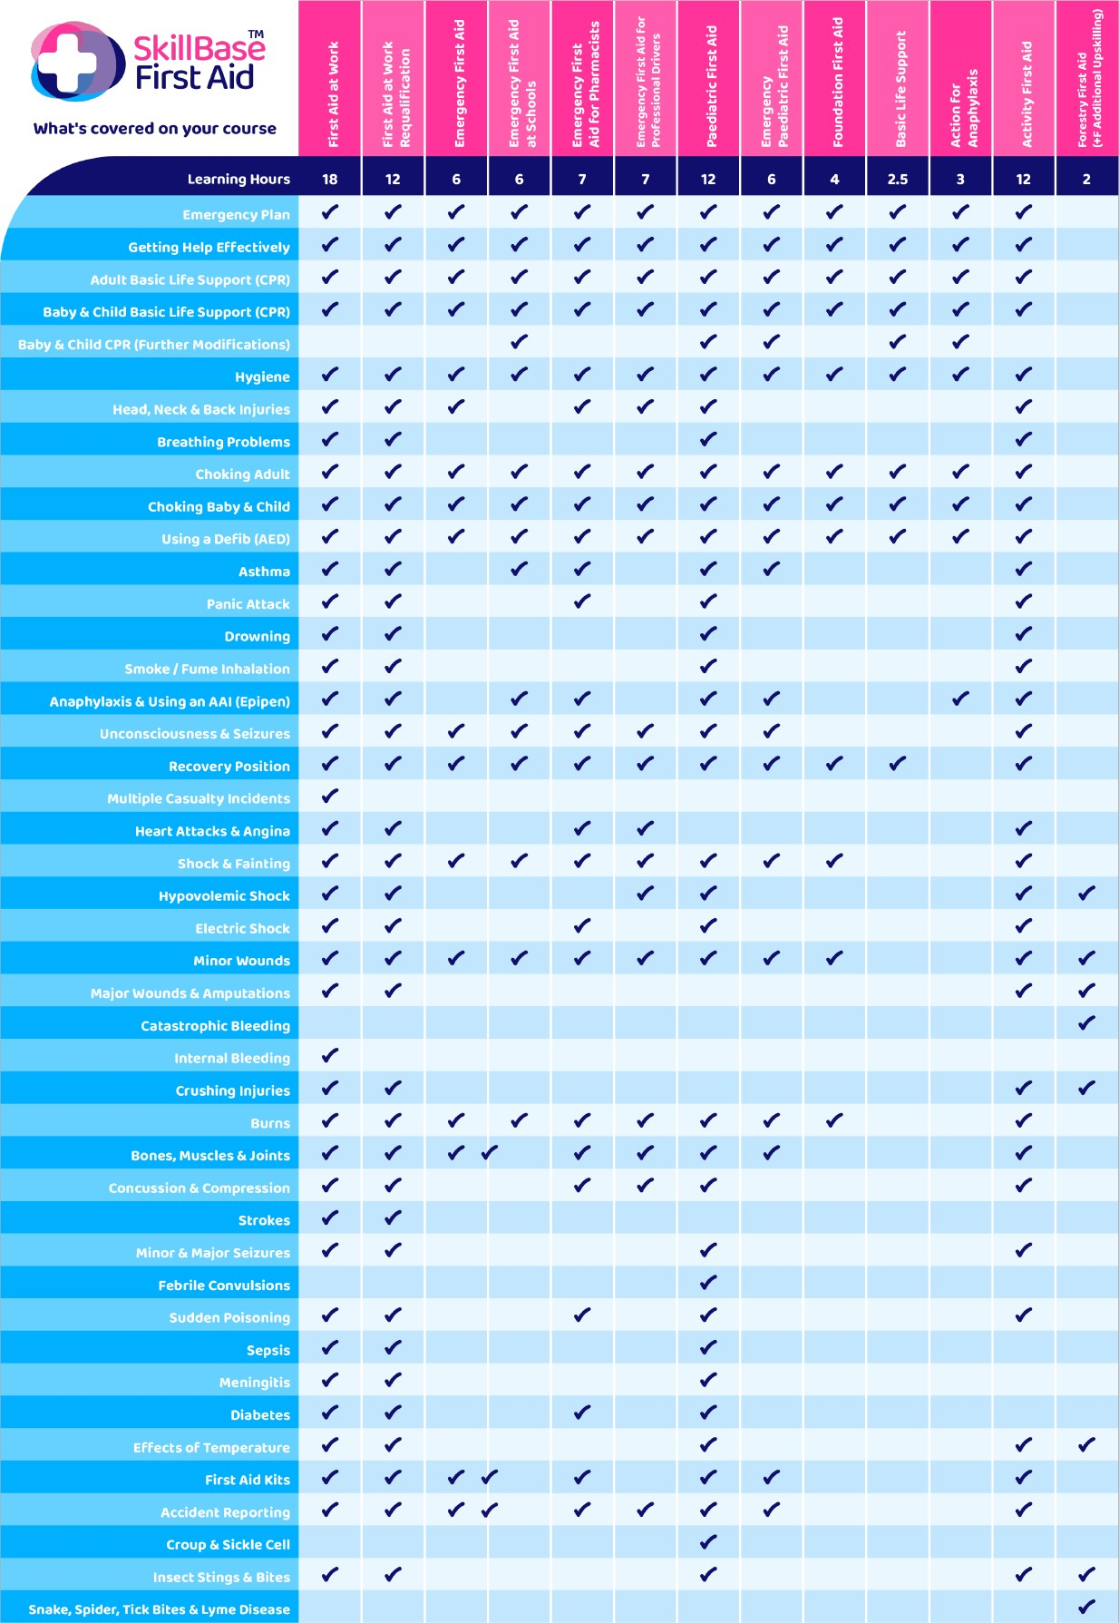Course contents are subject to change without prior notice in line with First Aid compliance and regulations. Details can be found on our website at skillbasefirstaid.com